ECO-TALANTA – (E-COMMERCE WEB PORTAL)

Peter Irungu Mwangi
SCT321-C004-2079/2018
Department of Physical and Applied Sciences
School of Computing and Informatics,
Jomo Kenyatta University of Agriculture and Technology

March, 2019.
CHAPETR ONE
Introduction
E-commerce is the production, distribution, marketing, sales or delivery of goods and services by electronic means (as defined by World Trade Organization, WTO). e-commerce depicts commercial transactions, involving both organizations and individuals, that are based upon the processing and transmission of digitized data, including text, sound and visuals images and that are carried out over open networks (like, the internet) or closed networks that have gateway onto an open network (Pallavi Dinodia, n.d.).
The steady shift of consumer behaviour to online shopping from retail stores hasn't been lost on electronic device manufacturers. Electronic commerce is yet another way to purchase online items from electronic storefronts or online services from automated service providers. Computer-mediated networks enable these transaction processes through electronic store searches and electronic point-of-sale capabilities. Other mobile devices include dash-top mobile devices, personal digital assistants or smartphones.

Overview of eco-talanta

Project aims and objectives

Project scope

CHAPTER TWO
Overview

Functional requirements

Non-functional requirements

Hardware tools

Software tools

CHAPTER THREE
Methodology
Outline of approach/development methodology used
The methodology is Object Oriented Analysis and Design (OOAD), is an iterative software development process that is used to develop the systems. OOAD is based on the content elements describing what to be produced and a step- by- step explanations describing how specific development goals are achieved (Roebuck, 2011).

The Rapid Prototyping Model
Technology is advancing so fast that the long lead time between setting requirements and delivering a final tested version of a product seems impractical. Rapid Prototyping Model is an iterative and requires creation of one or more prototypes as part of the software development process. Software is developed as a series of prototypes, with specifications of the individual prototypes changing in response to feedback from users (Jones & Richey, 2014).
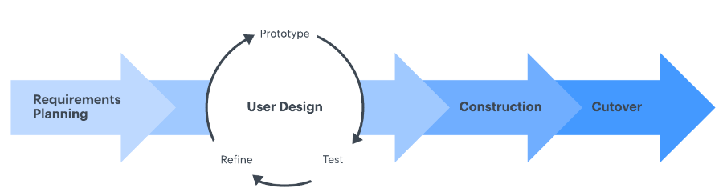
Figure 1 Rapid Application Development.
The process of prototyping involves the following steps

System Analysis
This is a stage that will give a detailed specification of the projects functional requirements and user requirements
It composes of the fact finding techniques that will be used for the development of the system i.e. questionnaires, interviews, observation and inspection

System design
This stage depicts the structure of the final system and explains how components will be structured and how they will operate and interact, where it is imposed in producing the system design specification that will satisfy the requirements specified during the analysis. It will compose of then following processes
- Interface design
- Logical design
- Physical design

Coding
After the design phase, the design will be translated into a set of program units which are accomplished by taking the components specification, studying it and creating a program unit to match the specification

Testing and integration
The customers, including end-users, examine the prototype and provide feedback on additions or changes .The testing techniques to be used are
- white box testing
- black box testing

Implementation
This is when the proposed system will be taken to users so that they can use it

Justification of the methodology
This methodology is useful because;
- Risks are usually discovered or addressed during integration. With the iterative approach, you can mitigate risks earlier.
- Increased quality; in terms of the development process and thus the quality of the developed system is assured.
- Less time is required for integration as the process goes on throughout the software development.
- It is flexible and adaptable to use in any environment. A good quality system is delivered at the end of the project.
- The development process itself can be improved and refined along the way

Schedule /plan activities and durations

References
Jones, T. S., & Richey, R. C. (2014). Rapid Prototyping Methodology in Action : A Developmental Study, (May). https://doi.org/10.1007/BF02313401
Pallavi Dinodia, A. T. (n.d.). E-commerce – International approach, 1–13.
Roebuck, K. (2011). Object-oriented Analysis and Design (OOAD): High-impact Strategies - What You Need to Know Definitions, Adoptions, Impact, Benefits, Maturity, Vendors. Tebbo.

